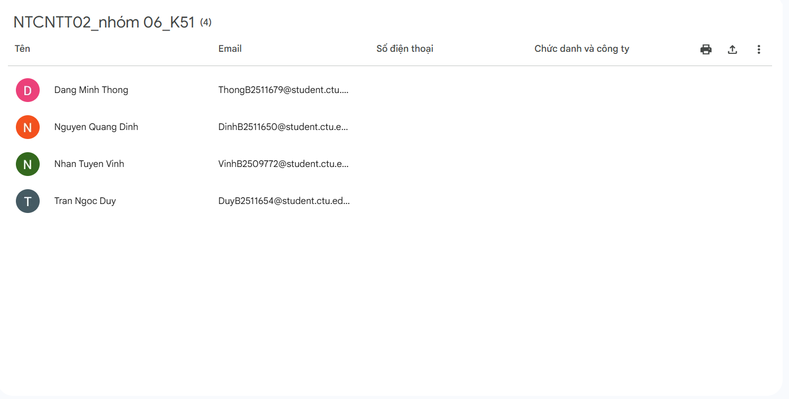
Link page: https://www.facebook.com/share/1Evq57XQYy/
Link Zalo: https://zalo.me/g/fdjhof195

